***NAME : Ibrar Babar***

**Roll no. 19P-0104**

**DLD LAB: (Tasks)**

**SECTION : 2B2**

***SIR YOUSAF***

***8:1 Multiplexer***

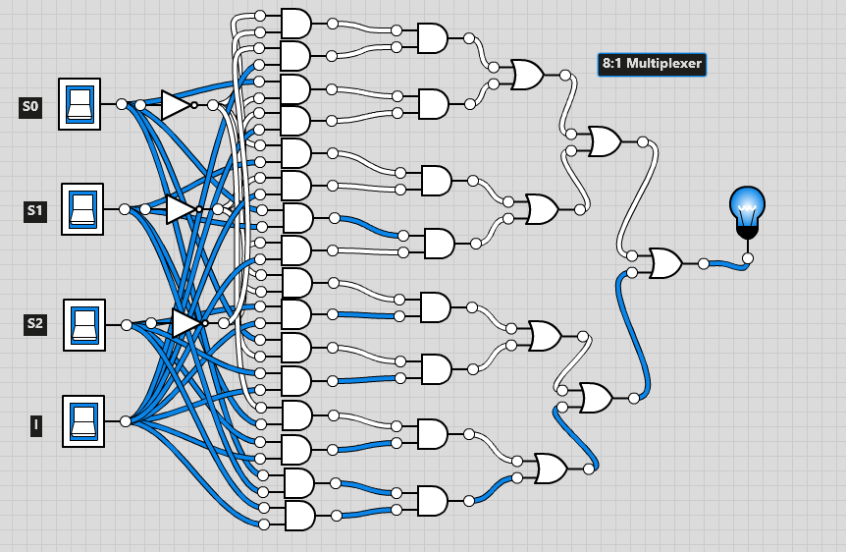

***Function implementation of 8*1 Multiplexer***

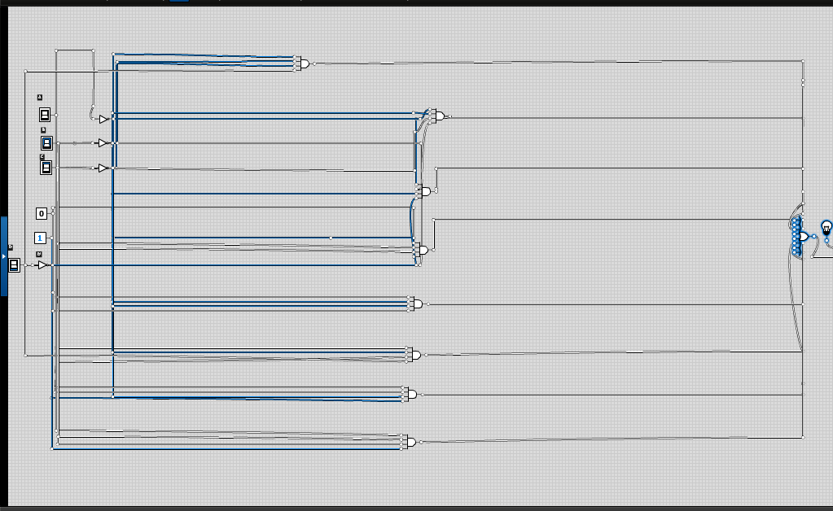

***ADDER***

